**A Major Project Phase-I Report**

**On**

**HAND GESTURE TO TEXT AND SPEECH CONVERTER**

Submitted To

**Chhattisgarh Swami Vivekanand Technical University Bhilai, India**

For

The Partial Fulfillment of Degree

of

**Bachelor of Technology**

*in*

**Computer Science & Engineering**

*By*

|  |  |  |
| --- | --- | --- |
| **Anjali Jha**  **Roll No.-303302219017**  **En. No.-BH3700**  **Semester 7th (CSE)** | **Sudhanshu Shukla**  **Roll No.-303302219108**  **En. No.-BH3791**  **Semester 7th (CSE)** | **Simran Banarase**  **Roll No.-303302219103**  **En. No.-BH3786**  **Semester 7th (CSE)** |

Under the Guidance of

**Mrs. Preeti Tuli**

Asst. Professor

Department of Computer Science & Engineering

S.S.I.P.M.T, Raipur

**________________________________________________________________**

**Department of Computer Science & Engineering**

**Shri Shankaracharya Institute of Professional Management & Technology Raipur (C.G.)**

**Session: 2022-23**

**HAND GESTURE TO TEXT AND SPEECH CONVERTER**

**DECLARATION BY THE CANDIDATE**

We the undersigned solemnly declare that the report of the Major Project Phase-I work entitled **Hand Gesture to Text and Speech Converter,** is based on my own work carried out during the course of my study under the supervision of Mrs. Preeti Tuli.

We assert that the statements made, and conclusions drawn are an outcome of the project work. We further declare that to the best of my knowledge and belief that the report does not contain any part of any work which has been submitted for the award of any other degree/diploma/certificate in this University/deemed University of India or any other country.

|  |  |  |
| --- | --- | --- |
| **(Signature of Candidate 1)**  **Name: Anjali Jha**  Roll No.:303302219017  En. No.: BH3700  Semester: 7th | **(Signature of Candidate 2)**  **Name: Sudhanshu Shukla**  Roll No.: 303302219108  En. No.: BH3791  Semester: 7th | **(Signature of Candidate 3)**  **Name: Simran Banarase**  Roll No.: 303302219103  En. No.: BH3786  Semester: 7th |

**CERTIFICATE OF THE SUPERVISOR**

This is to certify that the Major Project Phase-I report of entitled **Hand Gesture to Text and Speech Converter**is a record of bonafide research work/Project work carried out by **Anjali Jha** bearing Roll No.: **303302219017** & Enrollment No.: **BH3700,** **Sudhanshu Shukla** bearing Roll No.: **303302219108** & Enrollment No.: **BH3791, Simran Banarase** bearing Roll No.: **303302219103** & Enrollment No.: **BH3786** under my guidance and supervision for the partial fulfillment of Degree of Bachelor of Technology of Chhattisgarh Swami Vivekanand Technical University, Bhilai (C.G.), India.

To the best of my knowledge and belief the thesis embodies the work of the candidate him/herself, Has duly been completed, Fulfils the requirement of the Ordinance relating to the B.Tech degree of the University .Is up to the desired standard both in respect of contents and language for being referred to the examiners.

_______________________

(Signature of Supervisor)

**Mrs. Preeti Tuli**

Asst. Professor, Dept of CSE

S.S.I.P.M.T, Raipur, C.G

**Forwarded to**

**Chhattisgarh Swami Vivekanand Technical University, Bhilai**

_____________________ _____________________

(Signature of HOD)

**Dr. J.P.Patra**

HOD, Dept of CSE

S.S.I.P.M.T, Raipur, C.G

(Signature of the Principal)

**Dr. Alok Kumar Jain**

S.S.I.P.M.T, Raipur, C.G

|  |  |
| --- | --- |
|  |  |

**CERTIFICATE BY THE EXAMINERS**

The Thesis/Project entitled **Hand Gesture to Text and Speech Converter,**Submitted by**: Anjali Jha (Roll No.: 303302219017, Enrollment No.: BH3700), Sudhanshu Shukla (Roll No.: 303302219108, Enrollment No.: BH3791), Simran Banarase (Roll No.: 303302219103, Enrollment No.: BH3786)** has been examined by the undersigned as a part of the examination and is hereby recommended for the partial fulfillment of the degree of Bachelor of Technology of Chhattisgarh Swami Vivekanand Technical University, Bhilai.

|  |  |  |
| --- | --- | --- |
| **Internal Examiner**  **Date:** |  | **External Examiner**  **Date:** |

**ACKNOWLEDGEMENT**

We thank the almighty for giving us the encourage and perseverance in completing **“Hand Gesture to Text and Speech Converter”**. This project itself is acknowledgements for all those people who have given us their heartfelt co-operation in making this project a grand success. We extend our sincere thanks to **Mr. Nishant Tripathi, Chairman of our college,** for providing sufficient infrastructure and good environment in the college to complete our course.

We are thankful to our **Principal, Dr. Alok Kumar Jain** for providing the necessary infrastructure and labs and also permitting to carry out this project. With extreme jubilance and deepest gratitude, we would like to thank **Head of the Computer Science and Engineering Department, Dr. J.P.Patra** for his constant encouragement.

We are thankful to our project coordinator **Mr. Anand Tamrakar, Assistant Professor, CSE Department,** for his support and valuable suggestions regarding project work. We are greatly indebted to project guide **Mrs. Preeti Tuli, Assistant Professor, CSE Department,** for providing valuable guidance and support at every stage of this project work. We are profoundly grateful towards the unmatched services rendered by him. Our special thanks to all the faculty of Computer Science and Engineering and peers for their valuable advises at every stage of this work.

|  |  |  |
| --- | --- | --- |
| **(Signature of Candidate 1)**  **Name: Anjali Jha**  Roll No.: 303302219017  En. No.: BH3700  Semester: 7th | **(Signature of Candidate 2)**  **Name: Sudhanshu Shukla**  Roll No.: 303302219108  En. No.: BH3791  Semester: 7th | **(Signature of Candidate 3)**  **Name: Simran Banarase**  Roll No.: 303302219103  En. No.: BH3786  Semester: 7th |

**ACKNOWLEDGEMENT –AICTE IDEA Lab**

We have taken efforts in this project. However, it would not have been possible without the kind support and help of AICTE-IDEA Lab at SSIPMT, Raipur. We would like to extend our sincere thanks to all the gurus, mentors and support staff of Idea lab.

**LIST OF SYMBOLS**

|  |  |
| --- | --- |
| **,** | Comma |
| **.** | Full Stop |
| **,** | Inverted comma |
| **( )** | Parenthesis |
| **:** | Colon |
| **-** | Hyphen |
| **“ ”** | Double inverted comma |
| **[ ]** | Angle Bracket |

**LIST OF ABBREVIATIONS**

|  |  |
| --- | --- |
| **SRS** | System Requirement Specification |
| **DFD** | Data Flow Diagram |
| **UML** | Unified Modelling Language |
| **ER** | Entity Relationship |
| **ER-D** | Entity Relationship Diagram |
| **ASL** | American Sign Language |
| **LDA** | Linear Discriminant Analysis |

**LIST OF FIGURES**

|  |  |  |  |
| --- | --- | --- | --- |
| **S.No.** | **Figure No.** | **Description** | **Page No.** |
| 1 | 2.4 | Data Flow Diagram | 8 |
| 2 | 3.1 | Workflow Diagram | 9 |
| 3 | 3.2 | E-R Diagram | 11 |
| 4 | 3.3 | Use Case Diagram | 13 |
| 5 | 3.4 | Sequence & Activity Diagram | 15 |
| 6 | 3.5 | Collaboration & Class Diagram | 16 |
| 7 | 4.1 | Application Interface | 17 |
| 8 | 4.2 | Classifying Letter “C” | 17 |
| 9 | 4.3 | Classifying Letter “L” | 18 |
| 10 | 4.4 | Classifying Letter “A” | 18 |
| 11 | 4.5 | Classifying Letter “S” | 19 |
| 12 | 4.6 | Classifying Letter “S” | 19 |
| 13 | 4.7 | Display the text “CLASS” | 20 |

**ABSTRACT**

Sign Language Recognition is one of the most growing fields of research area. Many new techniques have been developed recently in this area. The Sign Language is mainly used for communication of deaf-dumb people. The proposed system contains four modules such as: pre-processing and hand segmentation, feature extraction, sign recognition and sign to text. By using image processing the segmentation can be done. Some of the features are extracted such as Eigen values and Eigen vectors which are used in recognition. The Linear Discriminant Analysis (LDA) algorithm was used for gesture recognition and recognized gesture is converted into text and voice format. The proposed system helps to dimensionality reduction.

Keywords:- Speech, Hand Gesture,, Image Processing

**TABLE OF CONTENTS**

|  |  |  |
| --- | --- | --- |
| **Chapter** | **Title** | **Page No.** |
|  | **DECLARATION BY THE CANDIDATE** | **I** |
| **CERTIFICATE OF THE SUPERVISOR** | **II** |
| **CERTIFICATE BY THE EXAMINERS** | **III** |
| **ACKNOWLEDGEMENT** | **IV** |
| **ACKNOWLEDGEMENT –AICTE IDEA Lab** | **V** |
| **LIST OF SYMBOLS** | **VI** |
| **LIST OF ABBREVIATIONS** | **VII** |
| **LIST OF FIGURES** | **VIII** |
| **ABSTRACT** | **IX** |
| I | **INTRODUCTION** | 1-2 |
|  | 1. Introduction | 1-2 |
| II | **LITERATURE REVIEW & PROBLEM IDENTIFICATION** | 3-8 |
| 2.1 Literature Review | 3-4 |
| 2.2 Problem Identification | 4 |
| 2.3 System Requirement analysis | 4-5 |
| 2.4 Data Flow Diagram | 5-8 |
| III | **METHODOLOGY** | 9-16 |
| 3.1 Workflow Diagram | 9 |
| 3.2 E-R Diagram | 10--11 |
| 3.3 Use Case Diagram | 12-13 |
| 3.4 Sequence & Activity Diagram | 14-15 |
| 3.5 Collaboration & Class Diagram | 16 |
| IV | **RESULT** | 17-20 |
|  | 4. Snapshot | 17 |
| V | **CONCLUSION** | 21 |
|  | 5. Conclusion | 21 |
| VI | **FUTURE SCOPE** | 22 |
|  | 6. Future Scope | 22 |
|  | **Reference** | 23 |

**CHAPTER-I**

**INTRODUCTION**

**1. Introduction**

American Sign Language (ASL) is natural syntax that has the same etymological homes as being speaking languages, having completely different grammar, ASL can be express with destiny of actions of the body. In native America, people who are deaf or can’t see, it’s a reliable source of absurdity. There is not any formal or familiar form of sign language. Different signal languages are speculating in particular areas. For a case, British Sign Language (BSL) is an entirely different language from an ASL, and USA people who familiarise with ASL would not easily understand BSL. Some nations adopt capabilities of ASL of their sign languages. Sign language is a way of verbal exchange via human beings diminished by speech and listening to loss. Around 360 million human beings globally be afflicted via unable to hearing loss out of which 328000000 are adults and 32000000 children. hearing impairment extra than 40 decibels in the better listening to ear is referred as disabling listening to loss.

Thus, with growing range of people with deafness, there is moreover a rise in demand for translators. Minimizing the verbal exchange gap among listening to impaired and regular humans turns into a want to make certain effective conversation among all. Sign language translation is one of the amongst most growing line of research nowadays and its miles the maximum natural manner of communication for the humans with hearing impairments. A hand gesture recognition gadget can offer an opportunity for deaf people to talk with vocal humans without the need of an interpreter. The system is built for the automated conversion of ASL into textual content and speech. A massive set of samples has been utilized in proposed device to understand isolated phrases from the same old American sign language which may be concerned about the use of virtual camera.

Considering all the sign language alphabets and terms, the database includes one thousand special gesture images. The proposed system intends to understand some very fundamental elements of signal language and to translate them to text and audio. American Sign Language is a visible language. Along with the signing, the thoughts techniques linguistic data through the vision. The form, placement, motion of hands, in addition to facial expressions, frame movements, every play essential factor in convey facts. Sign language isn't a normal language each the entire USA. It Has its very own signal 6 language, and areas have vernaculars, like

the numerous languages are spoken anywhere inside the globally speaking language, the detection rate by the ASL language as in compare to the grammatical accuracy is of 90 % percentage of institutions commonly use Indian sign language. The amazing elements of India it [ISL] has a bit difference in signing however the grammar is identical at a few stages in the U.S.A. The Deaf humans in India remember the fact that it’s plenty better than one-of-a-kind sign languages on the grounds that it's far a natural method for them, they observe via the herbal interaction with the human beings around them. The stages of sign language acquisition are equal as spoken languages, the toddlers begin with the aid of rambling with their hands. Since India doesn't have many Institutions for growing Indian sign language there is lack of understanding a number of the human beings and some Institution indicates to select ASL over ISL without right knowledge.

**LITERATURE REVIEW & PROBLEM IDENTIFICATION**

**CHAPTER-II**

**2.1 Literature Review**

A various hand gestures were recognized with different methods by different researchers in which were implemented in different fields. The recognition of various hand gestures were done by vision based approaches, data glove based approaches, soft computing approaches like Artificial Neural Network, Fuzzy logic, Genetic Algorithm and others like PCA, Canonical Analysis, etc. The recognition techniques are divided into three broad categories such as Hand segmentation approaches, Feature extraction approaches and Gesture recognition approaches. “Application research on face detection technology uses Open CV technology in mobile augmented reality” introduces the typical technology. Open source computer vision library, Open CV for short is a cross-platform library computer vision based on open source distribution. The Open CV, with C language provides a very rich visual processing algorithm to write it part and combined with the characteristics of its open source. Data gloves and Vision based method are commonly used to interpret gestures for human computer interaction. The sensors attached to a glove that finger flexion into electrical signals for determining the hand posture in the data gloves method. The camera is used to capture the image gestures in the vision based method. The vision based method reduces the difficulties as in the glove based method.

“Hand gesture recognition and voice conversion system for dumb people” proposed lower the communication gap between the mute community and additionally the standard world. The projected methodology interprets language into speech. The system overcomes the necessary time difficulties of dumb people and improves their manner. Compared with existing system the projected arrangement is simple as well as compact and is possible to carry to any places. This system converts the language in associate text into voice that's well explicable by blind and ancient people. The language interprets into some text kind displayed on the digital display screen, to facilitate the deaf people likewise. In world applications, this system is helpful for deaf and dumb of us those cannot communicate with ancient person. Conversion of RGB to gray scale and gray scale to binary conversion introduced in the intelligent sign language recognition using image processing. Basically any colour image is a combination of red, green, blue colour. A computer vision system is implemented to select whether to

differentiate objects using colour or black and white and, if colour, to decide what colour space to use (red, green, blue or hue, saturation, luminosity).

**2 .2 Problem Identification**

The problem statement centres around the concept of a camera-based sign language recognition system for the deaf, which would transform sign language gestures to text and subsequently text to speech. Our goal is to create a user-friendly and straightforward solution.

Dumb individuals communicate via hand signs, thus normal folks have a hard time understanding what they're saying. As a result, systems that recognise various signs and deliver information to ordinary people are required.

**2.3 System Requirement Analysis**

The SRS is a specification for a specific software product, program, or set of applications that perform particular functions in a specific environment.

**2.3.1 Software Requirements**

* **VS Code**

Visual Studio Code is a streamlined code editor with support for development operations like debugging, task running, and version control. It aims to provide just the tools a developer needs for a quick code-build-debug cycle and leaves more complexworkflows to fuller featured IDEs, such as Visual Studio IDE.

* **Python**

Python is an interpreted, object-oriented, high-level programming language with dynamic semantics. Its high-level built-in data structures, combined with dynamic typing and dynamic binding, make it very attractive for Rapid Application Development, as well as for use as a scripting or glue language to connect existing components together.

**2.3.2 Module Requirements**

* **Numpy** :-

NumPy is a Python library used for working with arrays. It also has functions for working in domain of linear algebra, fourier transform, and matrices.

* **Open Cv :-**

OpenCV is a cross-platform library using which we can develop real-time computer vision applications. It mainly focuses on image processing, video capture and analysis including features like face detection and object detection.

* **Pillow :-**Python Imaging Library (expansion of PIL) is the de facto image processing package for Python language. It incorporates lightweight image processing tools that aids in editing, creating and saving images.
* **Tensorflow :-**

TensorFlow is an open source framework developed by Google researchers to run machine learning, deep learning and other statistical and predictive analytics workloads.

* **Mediapipe :-**

MediaPipe is an open-source framework for building pipelines to perform computer vision inference over arbitrary sensory data such as video or audio.

* **Keras :-**

Keras is an Open Source Neural Network library written in Python that runs on top of Tensorflow.

**2.3.3 Hardware Requirement**

* Processors: i3,i5,i7 processor
* Disk space: 1 GB or more
* Operating systems: Windows 7 or later, macOS, and Linux

**2.4 Data Flow Diagram**

A Data Flow Diagram (DFD) is a traditional visual representation of the information flows within a system. A neat and clear DFD can depict the right amount of the system requirement graphically. It can be manual, automated, or a combination of both. It shows how data enters and leaves the system, what changes the information, and where data is stored.

The objective of a DFD is to show the scope and boundaries of a system as a whole. It

may be used as a communication tool between a system analyst and any person who plays a part in the order that acts as a starting point for redesigning a system. The DFD is also called as a data flow graph or bubble chart.

The Data Flow Diagram has 4 components:

* Process:

Input to output transformation in a system takes place because of process function. The symbols of a process are rectangular with rounded corners, oval, rectangle or a circle.

* Data Flow:

Data flow describes the information transferring between different parts of the systems. The arrow symbol is the symbol of data flow. A relatable name should be given to the flow to determine the information which is being moved. Data flow also represents material along with information that is being moved.

* Warehouse:

The data is stored in the warehouse for later use. Two horizontal lines represent the symbol of the store. The warehouse is simply not restricted to being a data file rather it can be anything like a folder with documents, an optical disc, a filing cabinet.

* Terminator:

The Terminator is an external entity that stands outside of the system and communicates with the system.

A data flow diagram can dive into progressively more detail by using levels and layers, zeroing in on a particular piece. DFD levels are numbered 0, 1 or 2, and occasionally go to even Level 3 or beyond. The necessary level of detail depends on the scope of what you are trying to accomplish.

* **DFD level** 0 is also known as fundamental system model, or context diagram represents the entire software requirement as a single bubble with input and output data denoted by incoming and outgoing arrows. Then the system is decomposed and described as a DFD with multiple bubbles. Parts of the system represented by each of these bubbles are then decomposed and documented as more and more detailed DFDs. This process may be repeated at as many levels as necessary until the program at hand is well understood. It is essential to preserve the number of inputs and outputsbetween levels, this concept is called leveling by DeMacro. Thus, if bubble "A" has two inputs x 1 and x2 and one output y, then the expanded DFD, that represents "A" should have exactly two external inputs and one external output.
* **DFD Level** 1 provides a more detailed breakout of pieces of the Context Level Diagram. You will highlight the main functions carried out by the system, as you break down the high-level process of the Context Diagram into its subprocesses.
* **DFD Level** 2 then goes one step deeper into parts of Level 1. It may require more text to reach the necessary level of detail about the system's functioning.

CAMERA

USER

**Fig. 2.4 Data Flow Diagram**

TRANSFORM TO FRAME

PREDICTING THE GESTURE

CNN

EXTRACT HAND

OPEN CV

**CHAPTER-III**

**METHODOLOGY**

**3.1 Workflow Diagram**

A workflow diagram (also known as a workflow) provides a graphic overview of the business process. Using standardized symbols and shapes, the workflow shows step by step how your work is completed from start to finish. It also shows who is responsible for work at what point in the process.

Designing a workflow involves first conducting a thorough workflow analysis, which can expose potential weaknesses. A workflow analysis can help you define, standardize and identify critical areas of your process.

A workflow chart is commonly used for documentation and implementation purposes since it provides a general overview of a business process. It's often the foundation for other documentation including flowcharts, data flow diagram, projects and more.

Hand Detection Tracking

Hand Region Segmentation

Image Acquisition from Camera

Display as Text

Classified Gesture

Hand Posture Recognition

**Fig. 3.1 Workflow Diagram**

**3.2 E-R Diagram**

ERD stands for entity relationship diagram. People also call these types of diagrams ER diagrams and Entity Relationship Models. An ERD visualizes the relationships between entities like people, things, or concepts in a database. An ERD will also often visualize the attributes of these entities.

By defining the entities, their attributes, and showing the relationships between them, an ER diagram can illustrate the logical structure of databases. This is useful for engineers hoping to either document a database as it exists or sketch out a design of a new database.

An ER diagram can help businesses document existing databases and thereby troubleshoot logic or deployment problems or spot inefficiencies and help improve processes when a business wants to undertake business process re-engineering. ERDs can also be used to design and model new databases and make sure that engineers can identify any logic or designflaws before they're implemented in production.

* Document an existing database structure
* Debug, troubleshoot, and analyze
* Design a new database
* Gather design requirements
* Business process re-engineering **(BPR)**

When documenting a system or process, looking at the system in multiple ways increases the understanding of that system. ERD diagrams are commonly used in conjunction with a data flow diagram to display the contents of a data store. They help us to visualize how data is connected in a general way, and are particularly useful for constructing a relational database.

Feature Extraction

Training Dataset

Preprocessing

Text/Audio

Classification

Feature Extraction

Preprocessing

Image or Video Acquisition

**Fig. 3.2 E-R Diagram**

**3.3 Use Case Diagram**

In the Unified Modeling Language (UML), a use case diagram can summarize the details of your system's users (also known as actors) and their interactions with the system. To build one, you'll use a set of specialized symbols and connectors. A use case diagram doesn't go into a lot of detail—for example, don't expect it to model the order in which steps are performed. Instead, a proper use case diagram depicts a high-level overview of the relationship between use cases, actors, and systems. Experts recommend that use case diagrams be used to supplement a more descriptive textual use case.

UML is the modeling toolkit that you can use to build your diagrams. Use cases are represented with a labeled oval shape. Stick figures represent actors in the process, and the actor's participation in the system is modeled with a line between the actor and use case. To depict the system boundary, draw a box around the use case itself.

The actors are on the outside of the system's border, whilst the use cases are on the inside. The behaviour of the system as viewed through the eyes of the actor is described in a use case. It explains the system's role as a series of events that result in a visible consequence for the actor. Use Case Diagrams: What Are They Good For? The objective of a use case diagram is to capture a system's dynamic nature.. However, this definition is too generic to describe the purpose, as other four diagrams (activity, sequence, collaboration, and State chart) also have the same purpose. We will look into some specific purpose, which will distinguish it from other four diagrams.

START WEBCAM

CAPTURE VIDEO

USER

SYSTEM

TRANSLATE GESTURE

DISPLAY RESULT

CAPTURE GESTURE

MATCH FEATURE

EXTRACT FEATURE

**Fig. 3.3 Use Case Diagram**

**3.4 Sequence & Activity Diagram**

A sequence diagram is a type of interaction diagram because it describes how and in what order group of objects works together. These diagrams are used by software developers and business professionals to understand requirements for a new system or to document an existing process. Sequence diagrams are sometimes known as event diagrams or event scenarios.

Sequence diagrams can be useful references for businesses and other organizations. Try drawing a sequence diagram to:

* Represent the details of a UML use case.
* Model the logic of a sophisticated procedure, function, or operation.
* See how objects and components interact with each other to complete a process.
* Plan and understand the detailed functionality of an existing or future scenario

The following scenarios are ideal for using a sequence diagram:

* Usage scenario: A usage scenario is a diagram of how your system could potentially be used. It's a great way to make sure that you have worked through the logic of every usage scenario for the system.
* Method logic: Just as you might use a UML sequence diagram to explore the logic of a use case, you can use it to explore the logic of any function, procedure, or complex process.
* Service logic: If you consider a service to be a high-level method used by different clients, a sequence diagram is an ideal way to map that out.

NeuralNet CNN

OpenCV

Camera

Capture the actions

Process video stream

Transform video into frames

Segmentation image

Predict the label

display label

Show text

**Fig. 3.4 Sequence & Activity Diagram**

**3.5 Collaboration & Class Diagram**

Open cv

Camera

Videostream:binary

transformtoframe()  
segmentation() displayable()

Captureinput()

neuralnet

imageframe:image

predictlabel()

**Fig. 3.5 Collaboration & Class Diagram**

**CHAPTER-IV**

**RESULT**

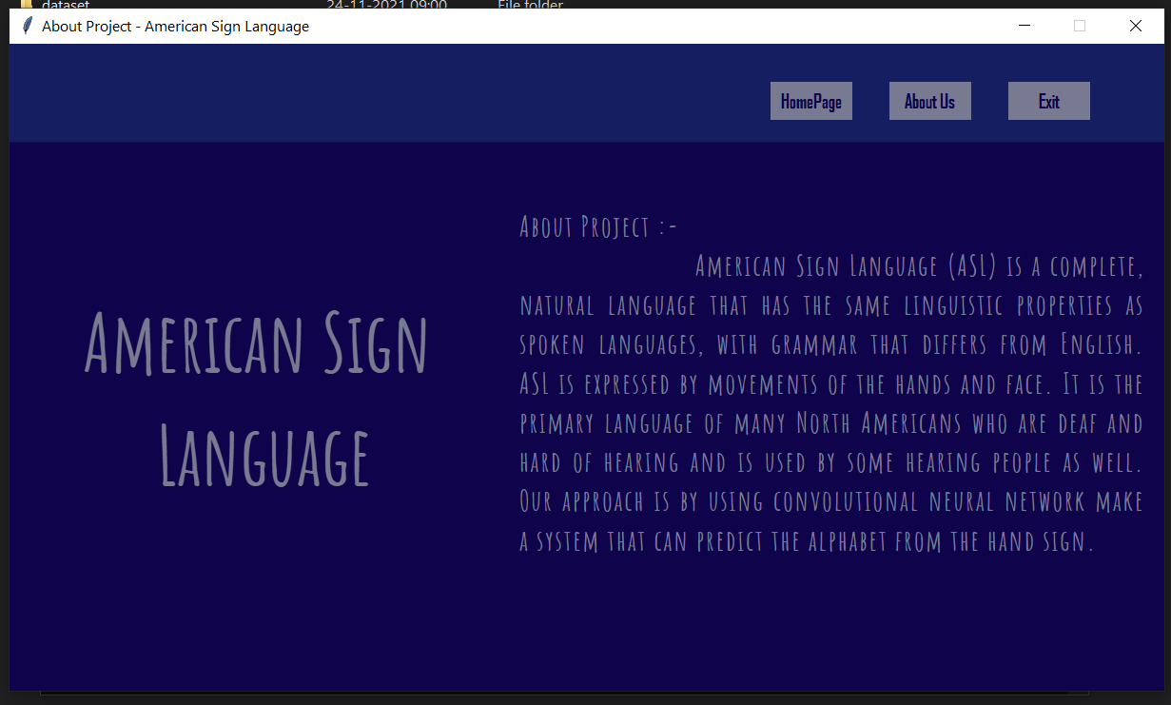**4. Snapshots**

**Fig. 4.1 Application Interface**

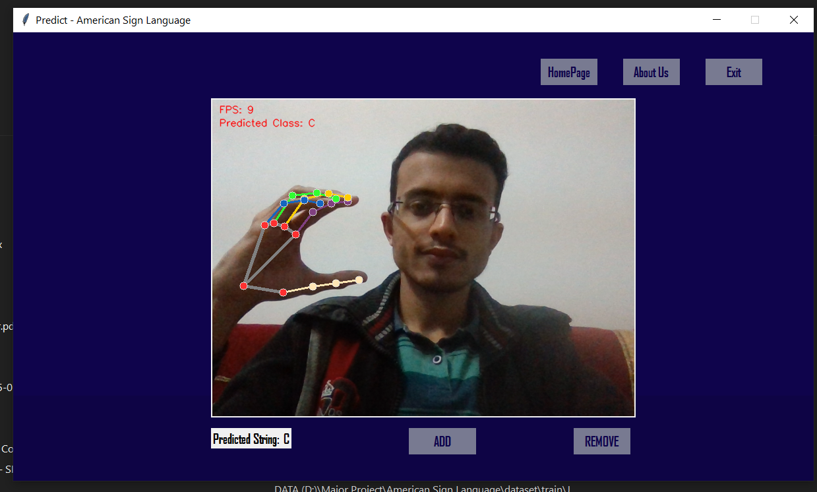**The following figure will show the recognizing of letters**

**Fig.4.2 Classifying letter “C”**

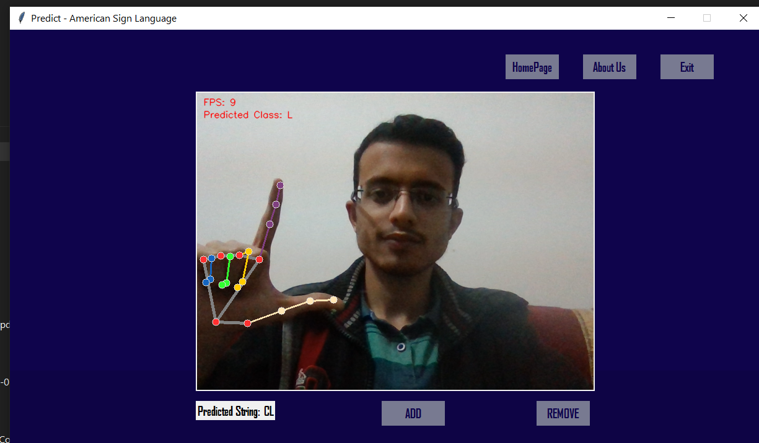

**Fig.4.3 Classifying letter “L”**

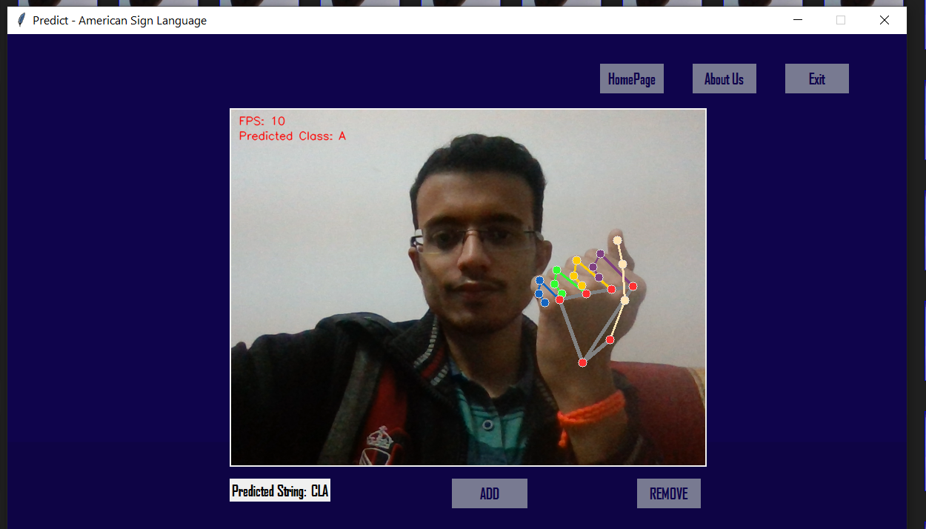

**Fig.4.4 Classifying letter “A”**

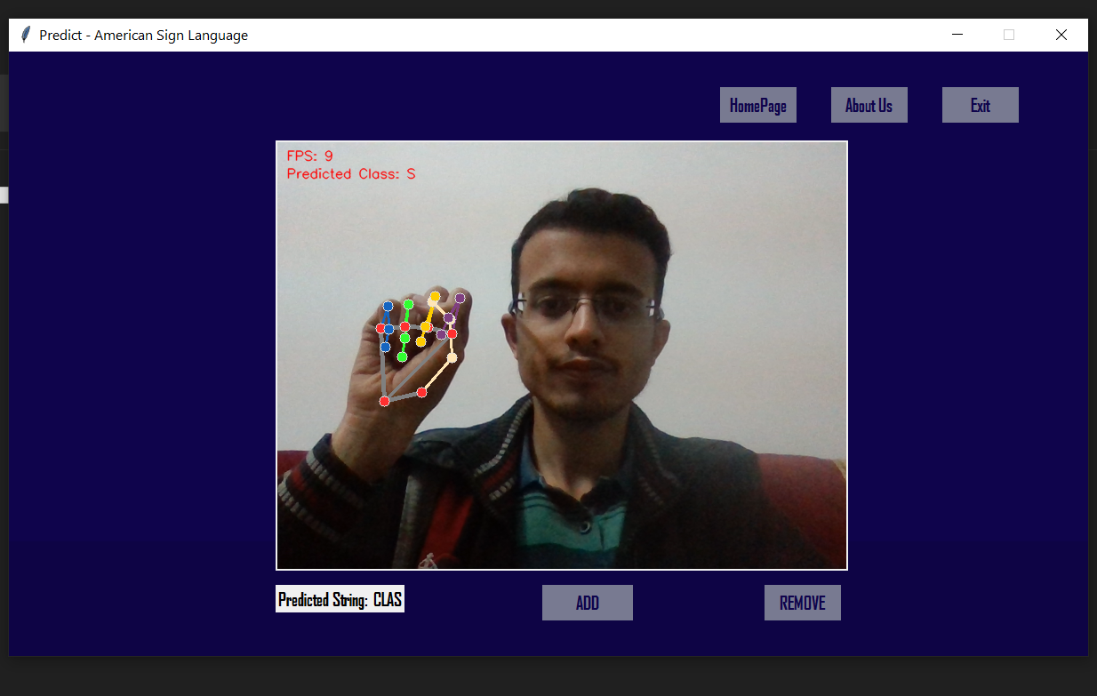

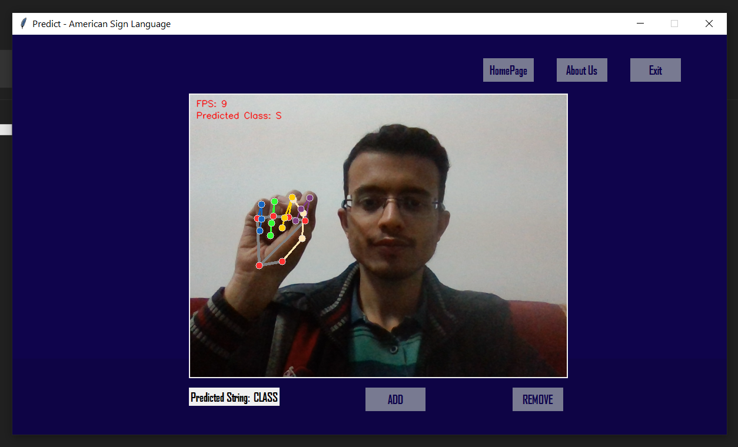

**Fig.4.5 Classifying letter “S”**

**Fig.4.6 Classifying letter “S”**

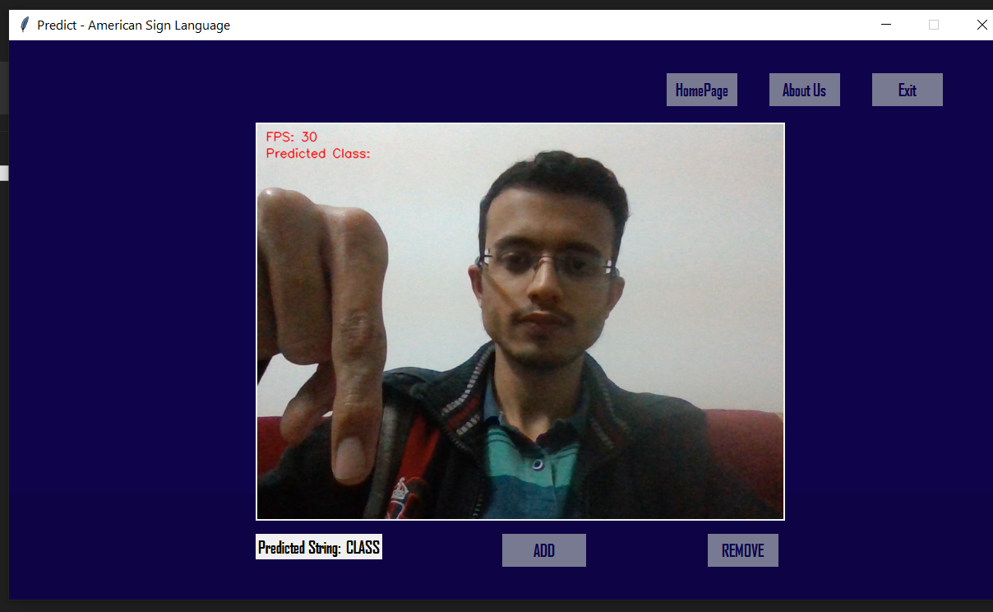

**Fig.4.7 Display the text “CLASS”**

**CHAPTER -V**

**CONCLUSION**

**5. Conclusion**

The practical adaption of the interface solution for visually impaired and blind people is limited by simplicity and usability in practical scenarios. As an easy and practical way to achieve human-computer- interaction, in this solution hand gesture to speech and text conversion has been used to facilitate the reduction of hardware components.

On the whole, the solution aims to provide aid to those in need thus ensuring social relevance. The people can easily communicate with each other. The user-friendly nature of the system ensure that people can use it without any difficulty and complexity. The application is cost efficient and eliminates the usage of expensive technology.

The project gives us the many advantages of usage area of sign language. After this system, it is an opportunity to use this type of system in any places such as schools, doctor offices, colleges, universities, airports, social services agencies, community service agencies and courts, briefly almost everywhere.

One of the most important demonstrations of the ability for communication to help sign language users communicate with each other occurred. Sign languages can be used everywhere when it is needed and it would reach various local areas. The future works are about developing mobile application of such system that enables everyone be able to speak with deaf people.

**CHAPTER-VI**

**FUTURE SCOPE**

**6. Future Scope**

This is an effective hand gesture recognition system to address the problem of extracting frames from a video and processing it. In the future scope, various hand gestures can be recognized and applied as input to the computer. The hand gestures representing numbers can also be converted into commands to perform related tasks in real time. Enhancing the recognition capability for various lightning conditions, which is encountered as a challenge in this project can be worked upon in future.

**Reference**

[1] J.P. Bonet. “Reducci_on de las letras y arte para ense~nar a hablar a los mudos”, Coleccion Cl_asicos Pepe. C.E.P.E., 1992.

[2] William C. Stokoe. Sign Language Structure [microform] / William C. Stokoe. Distributed by ERIC Clearinghouse, [Washington, D.C.], 1978.

[3] William C. Stokoe, Dorothy C Casterline, and Carl G Croneberg. “A Dictionary of American Sign Language on Linguistic Principles” Linstok Press, [Silver Spring, Md.], New Edition, 1976.

[4]Guo D, Zhou W, Wang M, Li H. Sign language recognition based on adaptive HMMS with data augmentation. Proceedings - International Conference on Image Processing, ICIP. 2016; 2016-Augus: p. 2876-2880

[5] Jin CM, Omar Z, Jaward MH. A mobile application of American sign language translation via image processing algorithms. Proceedings - 2016 IEEE Region 10 Symposium, TENSYMP 2016. 2016;: p. 104-109.

[6] Shahriar S, Siddiquee A, Islam T, Ghosh A, Chakraborty R, Khan AI, et al. Real-Time American Sign Language Recognition Using Skin Segmentation and Image Category Classification with Convolutional Neural Network and Deep Learning. IEEE Region 10 Annual International Conference, Proceedings/TENCON. 2019; 2018-Octob(October): p. 1168-1171.

[7] Hore S, Chatterjee S, Santhi V, Dey N, Ashour AS, Balas VE, et al. Optimized Neural Networks. 2017;: p. 139-151